Verifying an AI-drafted laboratory-interpretation rule base before clinical audit: executable invariants, frozen source-concordance protocols and a hash-frozen benchmark applied to the open Hemoglyph engine
Original research article. Revision R9 (2026-10-28, condensed submission version), formatted for Computer Methods and Programs in Biomedicine. Research prototype — not approved or intended for clinical use.
Sobhan Bahrami^{a*}, Zhaleh Tahmasebinejad^{b,c}, Ehsan Bahrami Samani^{b}
ª Allameh Helli 10 High School (NODET), Tehran, Iran. ^{b} Statistics and Data Science Clinic, Faculty of Mathematical Sciences, Shahid Beheshti University, Tehran, Iran. ^{c} Department of Epidemiology and Biostatistics, Research Institute for Endocrine Sciences, Shahid Beheshti University of Medical Sciences, Tehran, Iran [affiliation wording to be confirmed by Z.T.].
\* Corresponding author: sobahramisamani@gmail.com · ORCID 0009-0004-6639-5081
Highlights
- Four frozen, reproducible methods verify an AI-drafted lab rule base pre-review
- Executable invariants found a ranking defect that 353 adversarial vignettes missed
- Frozen provenance audits: 92% of rules unverifiable by locator; 1.1% drive output
- Unit-invariant in 40/40 panels vs 8/40 for an LLM; cuts LLM unsupported claims 40%
- Held-out mutation test and one-command clean-clone reproduction; no clinical claim

Abstract
Background and Objective: An LLM-drafted clinical rule base is a set of unread hypotheses about what guidelines say; vignette validation misses mistranscription and ranking defects, and reviewing every rule is impractical. We asked what can be established before such review, for Hemoglyph, an offline engine that ranks a cited laboratory-panel differential with 33,183 rules (99.2% AI-drafted).
Methods: Four pre-frozen methods: invariant tests (determinism, unit invariance, monotonicity, absent analyte) on random panels, on real panels shared with an LLM and as a verifier behind it; a source-concordance audit of 200 sampled rules, then of 100 rules an activity log over 3,814 real panels showed drive output; a hash-frozen one-shot benchmark on 2,314 ICU stays, 9,000 NHANES adults, 14,420 sepsis patients and external cohorts against supervised, prevalence and blinded LLM comparators; and an audit of the audit: core sufficiency, in-sample and held-out mutation recall, transfer to a second LLM-written corpus.
Results: The invariants exposed a ranking defect 353 vignettes had missed. Of 200 audited rules, 92% (95% CI 87.4–95.1) were unresolvable from their locators and ≥7.5% discordant. Only 364 rules (1.1%) ever drove a top-10 differential; of 100 sampled, 6 were concordant. 60.8% (58.7–62.9) of clinician-listed ICU diagnoses ranked top-five (prevalence baseline 51.3%); sepsis prediction failed as pre-specified. Engine and LLM recall@5 did not differ detectably (60.7% vs 59.6%; +1.2 points, 95% CI −2.5 to +5.1; no equivalence margin). SI units left the engine's top five unchanged in 40/40 panels, the LLM's in 8/40; as a verifier it cut the LLM's unsupported top-5 assertions from 9.4% to 5.7% for 0.2 recall points. The 335 curated or quote-verified rules alone kept recall@3/@5 within 0.2 points (@10 −1.2). Static detectors caught 74–100% of structural mutants, ≤13% of plausible wrong thresholds and almost no held-out population-gate or ±20% defects.
Conclusions: The methods are cheap, one-command reproducible and here unfavourable: provenance granularity limits auditability, 1% of rules carries the output, static checks miss plausible errors. A traceable engine did not differ detectably from a frontier LLM and can verify it. No clinician audited the rules and no clinical claim is made; code, rules, outputs and a human-audit protocol are public.
Keywords: Clinical decision support; Knowledge base; Software verification; Provenance; Laboratory medicine; Large language models

1. Introduction
Roughly 70% of clinical decisions draw on laboratory results, yet few reports carry an interpretive comment and post-analytical errors remain a leading source of diagnostic harm [1–3]. Each available remedy has a known weakness. Rule-based interpretation is transparent but narrow and expensive to maintain [4,5]. Supervised models need labelled data and cannot be audited clause by clause [6,7]. Large language models (LLMs) interpret reports fluently, but their answers vary between runs, the data leave the premises, and values are misclassified even when reference ranges are supplied [8–11].
LLMs have changed one part of this picture: a guideline-transcribed rule base that once took a committee years can now be drafted in weeks. This creates a software-engineering problem rather than solving a clinical one. An AI-drafted rule is a hypothesis about what a source says, nobody has read most of them, and the usual validation—authors' vignettes, one institution, no comparator [12]—detects neither mistranscription nor ranking defects. Diagnostic decision-support systems have been compared with GPT-4-class models on 36–201 symptom cases [13–16], formal verification has been applied to guideline knowledge acquisition [17] and external validation of learned models is mature [18], but no method exists for verifying a large AI-drafted laboratory rule base, and no openly licensed, machine-executable rule set for laboratory-panel interpretation was found to compare against (Supplementary Note 5).
This paper treats the rule base as software and asks how it can be verified. We contribute four methods: (i) a property-based test suite of invariants that any correct laboratory-interpretation engine must satisfy, run on randomised panels, as a black box on real panels given identically to the engine and to an LLM, and as a verifier behind the LLM; (ii) a source-concordance protocol, frozen before sampling and reported with explicit denominators, combined with an activity log that identifies which rules actually drive the output; (iii) a hash-frozen, one-shot, multi-dataset benchmark with supervised, prevalence and LLM comparators; and (iv) an audit of the audit, which tests whether the audited core is sufficient, how much the static detectors see in-sample and held-out, and whether the defects recur in a second LLM-written corpus. The tools require only that a rule be expressed as analyte, operator, threshold, unit, population gate and source locator, and are released standalone.
The object of study is Hemoglyph, an offline, single-process engine with 33,183 guideline-transcribed rules, 99.2% of them AI-drafted under a non-clinician first author and none clinically audited. The same engine ships inside a proprietary desktop product owned by the first author; this interest is declared and motivated the frozen design. The paper does not claim that the engine is accurate. It claims that the engine is verifiable, shows what verification found, and releases a pre-specified protocol for the clinical audit that should follow (Supplementary Note 19). Only the inference engine, fed with structured analyte–value pairs, is evaluated.

2. Methods

2.1 Engine under study
Hemoglyph processes a panel in five stages (Fig. 1): normalisation (UCUM units, aliases, age- and sex-specific reference intervals, 100 derived indices); a rule layer over registry 14.1.0, whose 33,183 executable records each hold a condition on at least one analyte, a population gate, an evidence role (diagnostic criterion, weight 6; supportive or screening, weight 3), a disease identifier and a source locator; an expert syndrome layer of about 900 multi-analyte constellations; fixed-weight fusion (0.35 rule engine, 0.25 Bayesian, 0.20 fuzzy, 0.10 knowledge graph, 0.10 risk models; set by judgement, never tuned on evaluation data), under which the fused score cannot fall below 0.90 × the rule-layer vote; and ranking hygiene (causal attribution, covering-diagnosis suppression, KDIGO chronicity [19], ADA glycaemic criteria [20], UDMI acuity [21]; 25 entries at most). Of the rules, 24,293 (73.2%) are generated two-analyte templates that rank below diseases and cite only a generic standards page; 8,890 attach to 2,502 disease, finding, drug-level or serology entities. No parameter was fitted to any patient record (change log: Supplementary Table S1).

2.2 Knowledge-base construction and provenance
For each guideline source the first author prompted a general-purpose LLM with the source text or citation and a fixed JSON schema. Returned records were accepted or rejected by automated audits only—schema validity, analyte present in the 2,045-analyte feature registry, convertible unit, plausible threshold, no duplicate or contradiction, context gate present, locator resolvable—and carry the status candidate_requires_specialist_validation. The 272 anchor rules were written or line-edited by hand from primary guideline text. No human read the bulk, so we call the registry AI-drafted and automatically audited. Registry 14.1.0 has 33,183 rules and 785 sources.

2.3 Verification method 1: executable invariants
A property-based suite of 25 tests generates randomised panels and asserts determinism; unit invariance (SI and conventional units give the same ranking, tolerance 10⁻³); directional monotonicity (a more extreme value never lowers the probability of the finding it defines; 14 analyte–direction pairs); absent-analyte invariance (no syndrome is asserted from an analyte that is not present); and context invariants (documented chronic kidney disease never raises acute kidney injury). It runs on every release with 353 adversarial vignettes and a safety battery, and tests logical consistency, not clinical correctness: a mistranscribed threshold passes every invariant.
Because the same properties can be stated for any reader, four were also run as a black-box benchmark in which the engine and the LLM of Section 2.5 received identical real panels: 40 eICU panels in SI units, the same 40 shuffled with five normal distractors, 20 creatinine ladders (×1.0, ×1.5, ×2.0) and 40 panels with the defining analyte of a criterion-met diagnosis removed. Panels, scorer and metrics were committed before any reading and are released as LabPanel-Check, a 290-panel conformance package (Supplementary Note 13). Finally, the same criteria served as an executable verifier behind the LLM: each entry of the 400 stored blind readings was checked against its own panel as supported, contradicted, analyte-absent or not verifiable; unsupported entries were demoted and recall re-scored, and the engine's own top five passed through the same verifier. A verified consensus arm (reciprocal-rank fusion of the engine's ranking with the supported LLM entries) was registered with the rule that recall@5 below 62% would be reported as "not complementary" (Supplementary Note 14). No new LLM call was made.

2.4 Verification method 2: source concordance and activity-guided provenance
Concordance. The protocol was frozen before sampling (seed 20261026). We drew 100 of the 272 curated anchors and 100 executable candidates (50 relevant to the ICU label set, 50 uniform from the rest) and compared analyte, operator and threshold with unit, population qualifier and disease attribution against the source reached from the registry locator, with Crossref title and PubMed abstract as fall-back for paywalled DOIs. Labels were CONCORDANT, DISCORDANT or UNRESOLVABLE, with the tie-break "when in doubt, unresolvable"; an unresolvable rule is never counted as concordant. Rates are reported with two denominators (resolvable; all sampled) and Wilson 95% CIs. The rater was an AI agent working under the first author's direction and is declared as such.
Activity. A second protocol, frozen with registered expectations, logged for every rule on 3,814 real panels (the 2,314 eICU stays and 1,500 NHANES 2015–18 adults; seed 20261027) whether it fired and whether its disease entered the top-10 differential; rules that contributed at least once form the active core. Each active rule's locator was searched automatically for its threshold, and 100 active rules outside the concordance sample were drawn (seed 20261028) and labelled by the same rater, this time with a verbatim quote required for every concordant or discordant verdict. No rule or locator was changed.

2.5 Verification method 3: frozen one-shot benchmark
An internal statistical analysis plan (Supplementary Note 1; 15 dated amendments) fixed metrics, label maps, thresholds and comparators; it was hash-frozen in the repository but not publicly registered, so we write "pre-specified", not "pre-registered". Before each of two quarantine rounds, code and registry were frozen with SHA-256 manifests and the quarantine data were run once. Round 1 failed two superiority criteria because a guideline-correctness change lowered CKD recall; the criteria were re-specified as non-inferiority before any round-2 file was opened, and round 2 met them, so round 2 is evidence of non-regression rather than the confirmatory test originally planned (Fig. 2a; Supplementary Table S2). Every number in Tables 1, 3–5 and 7 and Figures 2 and 4–8 comes from frozen engine v7 with registry 14.1.0; the black-box test (Table 6) and the audit study (Section 3.8) used the later engine v8.2 and registries 15.1.0–15.3.0, which change no v7 number (Supplementary Table S17).
Datasets and reference standards (Table 2; Supplementary Table S3). eICU-CRD demo v2.0.1 [22]: 2,314 adult stays with at least eight analytes in the first panel, the clinician problem list mapped to 31 groups as reference (mapping audit on 400 stays: precision 100%, sensitivity 98.3%). MIMIC-IV demo [23]: 235 admissions, ICD-10. NHANES 2013–14, 2015–16 and 2017–18: 3,000 randomly sampled adults per cycle, referenced to ADA, KDIGO, WHO and ACG criteria and to self-report. PhysioNet/CinC 2019 [24]: sets A, B and B2 (14,420 patients), Sepsis-3 onset. UCI thyroid0387 [25], HCV [26], ILPD [27] and 50 PMC case reports [28].
Metrics and comparators. The primary metric is flat recall@k of clinician-listed diagnoses (k = 3, 5, 10); secondary metrics are two-tier recall, panel-supported recall, per-group AUROC, the false-assertion rate in all-normal adults, sepsis AUROC, calibration [29] and a component ablation. Comparators were a raw key-analyte threshold; gradient boosting and logistic regression on the same analytes (five-fold out-of-fold); a prevalence-ranking baseline; and an unnamed frontier LLM run by the authors through the Arena.ai agent platform (2026-10-21 to 2026-10-25; n = 400), which routes among several frontier model families without exposing model or version, so "unnamed frontier LLM" denotes a capability tier, not a verified identity. The LLM received the identical panel, age and sex with a fixed prompt requesting ten ranked diagnoses, blind to labels; 40 panels were re-read for test–retest; scoring used the engine's label map and script (Supplementary Note 2).
Statistics. Labels are nested in stays (ICC 0.04), so eICU proportions and paired differences use a stay-cluster bootstrap (4,000 resamples) and the cluster-adjusted McNemar test [30,31]; Wilson intervals elsewhere; DeLong or bootstrap intervals for AUROC; Benjamini–Hochberg correction across per-group tests. Reporting follows TRIPOD+AI [32], adapted for a system with no fitted parameters.

2.6 Verification method 4: verifying the verification
Three questions about the methods themselves were pre-specified, with protocol and detector code frozen before any result, and run on the post-audit registry 15.1.0. Sufficiency: an arm in which only 335 rules remain executable—284 curated rules, 19 further rules with a verbatim source quote and 32 reference-interval conventions—was run on the same cohorts and seeds as the full registry; "not load-bearing" (|Δ| ≤ 0.5 points) and "partially load-bearing" (0.5–3 points) were defined in advance. Mutation: seven static defect detectors, calibrated on 15.1.0 and then frozen, were scored for recall on eight classes of synthetic defect injected into 303 seed rules and for specificity on the unmutated seeds. Because that estimate is in-sample, a held-out test with eight further defect families was pre-registered afterwards, with its expected blind spots stated before the run, on 300 AI-drafted rules of registry 15.3.0 and on the external corpus below (Supplementary Note 20). Transfer: the detectors were run unchanged on registry 14.1.0 and on a second LLM-written rule set (200 entities × 2 rules, fixed prompt, no templates, hash-frozen before the run), written by the same agent that wrote the detectors; the test therefore asks whether the defect classes recur under a different generation process, not whether they are independent.

3. Results

3.1 Executable invariants
All 25 tests pass on the current engine. On the frozen v7 the suite exposed one defect that the 353 adversarial vignettes had not: a well-supported renal finding was capped beneath a presumptive explainer scoring below 0.80, so the leading renal probability fell as creatinine rose from 1.6 to 2.2 mg/dL. The fix applies an existing rule uniformly and passed the full gate (eICU recall@3/5/10 48.4/61.0/74.1% versus 47.9/60.8/74.1% for v7); the frozen v7 numbers reported below are unchanged. The engine is deterministic (byte-identical output in 50/50 repeated stays) and runs on one CPU core in about 1 s per panel without network calls.

3.2 Source concordance
Of 200 rules sampled under the frozen protocol (Fig. 3b), only 16 could be resolved from the locators the registry provides. Fifteen were discordant—7 attribution errors among curated anchors (a hypernatraemia rule citing the hyponatraemia guideline, for example) and 8 thresholds or definitions absent from an on-topic source (a candidate acute-kidney-injury "criterion" defined by a fixed creatinine > 1.1 mg/dL and attributed to KDIGO 2012, which defines AKI only by change from baseline)—and one was concordant. The remaining 184 (92%, 95% CI 87.4–95.1) were unresolvable: 12 with no retrievable text, 55 with only a title or abstract, 46 citing generic methodological standards that cannot contain a disease-specific threshold, and 71 organisation landing pages. Retrievability and verifiability proved to be different properties (Supplementary Table S18): a source opened to at least 500 characters of text for 94.0% (89.8–96.5) of sampled rules, but the encoded statement was found in it for only 8.0% (5.0–12.6). Because an attribution error is visible from a title while concordance needs the full text, 15/16 is not an estimate of the discordance rate. The defensible statements are that at least 7.5% (4.6–12.0) of sampled rules are demonstrably discordant and that the registry cannot be audited rule by rule from its own locators. The audit is single-rater, by a declared AI agent; no inter-rater reliability is claimed.

3.3 Activity-guided provenance audit
On 3,814 real panels, 1,991 rules fired, 364 (1.1%) ever placed a diagnosis in a top-10 differential, 174 did so ten or more times, and 31,192 (94.0%) never fired (Fig. 3a). The active core holds 46 of the 272 curated anchors and 105 generated templates. Automated search located a rule's threshold in a document reached from its locator for 8 of the 364 active rules. In the fresh sample of 100 active rules, 6 were concordant (ADA 2026 diabetes and prediabetes criteria, ADA/EASD 2024 DKA severity and HHS criteria, BSG 2021 iron-deficiency anaemia), 2 discordant (an HbA1c "> 5.7%" pattern against an inclusive 5.7–6.4% range; CK "≥ 1000" against "> 1000 U/L") and 92 unresolvable (85.0–95.9). None of the four registered expectations was met (Supplementary Note 15).

3.4 Intensive care (eICU-CRD demo)
In 2,314 adult ICU stays from 186 US hospitals, using the first panel alone, 47.9% (stay-clustered 95% CI 45.8–50.0) of 2,432 clinician-listed, laboratory-relevant diagnoses appeared in the top 3, 60.8% (58.7–62.9) in the top 5 and 74.1% (72.2–76.0) in the top 10 (Table 3). Precision@5 was 14.2% (13.3–15.2), F1@5 23.1% and NDCG@5 56.5% (54.1–58.8) against an incomplete problem list. Recall@5 ranged from 88.1% for acute myocardial infarction and 83.0% for anaemia down to 49.1% for sepsis and 35.8% for CKD. A prevalence-ranking baseline reached recall@5 51.3% and NDCG@5 39.0%, and overtook the engine at k = 10 (76.8% vs 74.1%): the engine's contribution is ordering, not coverage (Supplementary Table S11). Of the 10,380 top-5 assertions, 14.2% were on the problem list, 54.8% were uncoded but criterion-positive in the same panel, 12.6% were criterion-negative (the closest available estimate of false positives) and 18.4% fell in groups without a single-analyte criterion.
The reference standard bounds these numbers (Fig. 2b): of 2,707 label targets, 541 belonged to groups with no single laboratory criterion, 275 lacked the key analyte and 431 were contradicted by the first panel. Among the 1,460 labels whose first panel met the guideline criterion (a secondary metric defined after the ceiling was observed), flat recall was 29.6/62.5/78.0/91.8% at k = 1/3/5/10. Supervised models trained on the labels (Fig. 4) exceeded the untrained engine only in outcome-defined groups without a laboratory signature (sepsis AUROC 0.82 vs 0.68; gastrointestinal bleeding 0.85 vs 0.75; alcohol withdrawal 0.80 vs 0.54) and were matched or beaten in nine guideline-defined groups.

3.5 Ablation, community survey and external cohorts
Two components carry the signal (Table 1): removing the rule-engine vote cost 12.1 points of flat recall@5 (−14.4 to −9.8) and removing the syndrome layer 9.5 points (−11.1 to −7.9); the Bayesian network contributed 1.3 points and any fusion-weight profile changed recall by at most 1.4 points. Restricting the registry to the 272 curated anchors lowered recall@5 by 0.9 points (−2.1 to +0.2), so the headline rests on hand-curated components and registry scale is not claimed as a merit. In 3,000 NHANES adults per cycle, AUROCs reproduced across the development cycle (2017–18) and the two quarantine cycles (2013–14, 2015–16): diabetes 0.946/0.938/0.924, CKD 0.959/0.968/0.962, anaemia 0.972/0.994/0.983 (Fig. 5; Table 4); against self-reported physician diagnosis, which does not overlap the inputs, AUROC was 0.90–0.92 for diabetes and 0.75–0.82 for kidney disease, and among guideline-healthy adults the engine asserted a disease in 2 of 485 (0.4%). In PhysioNet/CinC 2019 the sepsis score discriminated Sepsis-3 onset with AUROC 0.600, 0.610 and 0.588 in sets A, B and B2, against 0.691, 0.712 and 0.679 for a supervised logistic model on the same features (Fig. 6)—a pre-specified negative result that was not tuned away. External cohorts, calibration (Fig. 8) and subgroups are in Table 4 and Supplementary Note 17.

3.6 Blinded comparison with an unnamed frontier LLM
On 400 stays (291 with scorable labels; 596 labels), recall@5—the pre-specified primary comparison—was 60.7% (56.5–65.0) for Hemoglyph and 59.6% (55.3–63.6) for the LLM, a difference of +1.2 points (−2.5 to +5.1; cluster-adjusted McNemar p = 0.54). The LLM was better at rank 1 (28.2% vs 24.0%, p = 0.013) and rank 3 (50.8% vs 47.0%, p = 0.041); the engine was better at rank 10 (72.0% vs 65.1%, p = 0.0002) and left fewer labels absent altogether (21.8% vs 34.9%); mean reciprocal rank was 0.391 vs 0.408 (Fig. 7; Table 5). On 40 panels re-read by the LLM, top-5 agreement with its own first reading was κ 0.69; the engine's was 1.00.

3.7 Black-box conformance and the engine as a verifier behind the LLM
Conformance (Table 6). SI units left the engine's top five identical in 40/40 panels (Jaccard 1.00) and the LLM's in 8/40 (0.72); shuffled order with distractors, 35/40 (0.96) against 10/40 (0.73); the LLM figures include its own test–retest variability. The first engine run gave 36/40 on SI units, and all four discrepancies traced to one defect the in-process suite had not reached—a record mirrored under a legacy identifier kept its reported unit, so a normal bilirubin of 9 µmol/L met an 8 mg/dL panic threshold. The fix has a regression test; the frozen v7 numbers are untouched. The engine violated creatinine monotonicity in 2 of 20 ladders at ×2.0 (logged, not changed). After removal of the defining analyte, the target remained at rank ≤ 5 in 3/40 engine and 14/40 LLM panels, and in a blinded NHANES test the engine asserted no disease in 40 guideline-healthy adults while the LLM did so in four (Supplementary Note 13).
Verifier (Table 7). Of 2,424 LLM entries, 1,636 mapped to a group with a criterion (1,439 supported, 182 contradicted, 15 analyte-absent) and 788 were not verifiable. Among mapped top-5 entries, 140 of 1,486 (9.4%) were unsupported (registered expectation 15–30%); the engine's own top five failed the same proxy criteria in 233 of 1,518 (15.3%; registered 5–15%), mostly where its hyperglycaemia and prerenal rules are more permissive than the criterion, but never without the analyte present (0/1,518). Demoting unsupported LLM entries left recall@5 essentially unchanged (59.6% → 59.4%; paired −0.2, 95% CI −0.5 to 0.0), raised recall@1 by 1.2 points (0.2–2.3; p = 0.014) and reduced the unsupported share to 5.7%; of 197 demoted entries, 10 were clinician labels (5.1%; registered ≤ 10%). The parameter-free fusion gave recall@1/5/10 of 21.8/61.2/76.3%—below the registered 62% at rank 5, better only at rank 10 (+4.5, CI 2.2–6.8) and worse on outcome-type labels (51.9% → 42.7%), because the filter admits only what is verifiable. Per protocol the systems are reported as not complementary; no other rule was tried (Supplementary Note 14).

3.8 Verifying the verification
Sufficiency. With only the 335 curated, quote-verified or convention rules executable, eICU flat recall@3/5/10 was 47.8/61.2/73.1% against 48.0/61.2/74.3% for the full registry 15.1.0, two-tier recall@1/3/5 was 32.3/60.9/70.1% against 33.3/62.3/72.4%, mean per-label AUROC 0.761 against 0.766, NHANES AUROCs were identical and healthy-adult false assertions 0/51 in both arms. Paired differences were significant only at @10 (p = 0.005), driven by diabetes and renal pattern templates: under the pre-stated thresholds the other 30,735 executable rules are not load-bearing at @3 and @5 and partially load-bearing at @10.
Mutation. In-sample detector recall (Fig. 3c) was 1.00 for inverted or impossible tiers (301/301), 0.98 for multi-analyte rules collapsed to a single ubiquitous analyte (138/141), 0.74 for unit substitution (113/152), 0.55 for thresholds pushed outside physiological limits (40/73), 0.46 for random source substitution (40/88), 0.13 for operator flips (36/274) and 0.003 for plausible threshold changes (1/303); specificity on unmutated seeds was 0.974, and four of the eight flagged seeds were real defects. These, with 126 unit-label and 14 source errors found during calibration, were corrected in registry 15.2.0 under a written protocol with every gate count identical before and after. The held-out test (Supplementary Note 20) showed where the in-sample figures hold and where they do not: unit-swap recall held at 0.81 on the 300 AI-drafted rules and 0.70 on the external corpus, but operator-flip recall fell to 0.035 on the external corpus, whose two-rules-per-entity structure gives the direction detector nothing to compare against; decimal-place errors were caught in 13–16%; a benign, consistent unit conversion was never flagged; and, as pre-stated, removing a population gate, swapping in a same-domain source, encoding a contradictory conjunction or shifting a threshold by 20% went undetected in at least 98% of cases.
Transfer and ledger. Per 100 rules, any-detector density was 23.6 (95% CI 22.8–24.5) in registry 14.1.0, 1.3 (1.0–1.6) in 15.1.0 and 12.8 (9.8–16.4) in the second LLM-written corpus, where 37 of 51 flags were true defects (Supplementary Note 16). A per-rule verification ledger (Fig. 3d; Supplementary Note 18) joins the four methods for the 605 curated, active-core or sufficiency-arm rules: of the 272 anchors, 18 are quote-verified, 8 discordant and 141 unresolvable; of the 364 active-core rules, 145 were retired, 37 are quote-verified and 157 unresolvable. It also exposed seven discordant rules, five open detector flags and one unimplemented protocol line left unchanged, all closed under a written protocol in registry 15.3.0 with the non-regression gate unchanged.
Reproduction. From a clean clone of the repository, one command rebuilt engine v7 from its git tag, checked it against the freeze manifests, re-ran the tests, the ledger, the mutation table and the frozen engine on NHANES and eICU, and reproduced every number in Tables 3 and 4 exactly (Supplementary Note 21). The first attempt failed because two inputs of the ledger existed only in the authors' working copy; they were committed and the run repeated.

4. Discussion
Each method produced information that conventional validation had not: two engine defects that 353 adversarial vignettes had missed; a rule base that cannot be audited from its own locators, with at least 7.5% of sampled rules discordant; an output carried by 1.1% of the rules, which fail in the same way as the bulk; recall@5 not detectably different from a frontier LLM while a prevalence baseline reached 51%, so that the engine's contribution is ordering (NDCG@5 56.5% vs 39.0%) and specificity rather than coverage; and an audited core of 335 rules that preserves recall@3 and @5 within 0.2 points at a cost of 1.2 points at @10.
Executable invariants are a genuine advantage of a rule engine over an LLM. They can be stated, run on every release and violated only visibly. On identical panels the engine held unit and presentation invariance where the LLM's output changed in most panels, and the same test found two engine defects: a violated invariant is a bug report with a reproducer, whereas an LLM's changed answer is not actionable. The criteria also work as a verifier behind the LLM, reducing its unsupported top-5 assertions from 9.4% to 5.7% for a change in recall@5 of −0.2 points; fusing the two systems did not help at rank 5, because filtering admits only the verifiable while the engine's residual advantage lies in outcome syndromes that no single criterion verifies. Invariants establish consistency, not correctness, and the held-out mutation test bounds how little else the static layer sees: a wrong but plausible number, a missing population gate or a wrong-but-on-topic citation passes it.
The concordance audit shows why correctness is hard to reach. The limiting factor was locator granularity, not rater effort: organisation-level URLs and generic standards make 92% of rules uncheckable, and where checking was possible the error was usually attribution. Audit protocols should therefore require the verbatim source sentence for every verdict, registries should carry section- or table-level locators, and an independent clinical audit is the next step; its protocol—50 active-core and 50 anchor rules, two blinded clinical raters, verbatim-quote verdicts, Cohen's κ, sample size and stopping rule—is fixed in Supplementary Note 19 before any rater is recruited.
The benchmark numbers measure the reference standard at least as much as the engine: a quarter of problem-list entries were not inferable from the first panel, the panel-supported subset is recovered at 78.0% (k = 5) and 91.8% (k = 10), and coded precision (14.2%) is a lower bound because 54.8% of uncoded top-5 assertions satisfy the group's criterion in the same panel. Where the engine loses—sepsis, bleeding, withdrawal, CKD without a second creatinine—the label is an outcome learned from hidden correlates or needs longitudinal data, and part of the loss was chosen: withdrawing single-creatinine CKD assertions to comply with KDIGO cost three points of recall@5.
Ablation and sufficiency agree that the result lives in the rule vote and a few hundred curated constellations. The bulk adds one to three points and 94% of it never fired, so the activity log converts an unauditable registry into a tractable verification queue: a release could ship only the 335 verified rules and carry the remaining 30,735 as labelled, off-by-default hypotheses until each is audited, at a measured cost of at most 0.2 points at @3 and @5 and 1.2 points at @10. The design answers the criticisms made of recent LLM benchmarks—unstable metrics, leakage and post-hoc selection [28,33]: releases were frozen with manifests, quarantine data were run once, the failed round is disclosed, the whole chain reproduces from a clean clone, and the LLM's own test–retest variability (κ 0.69) exceeded the between-system difference. Unlike the Isabel and DXplain studies [13–16,34], this study isolates laboratory-only reasoning on more than 20,000 encounters and releases its knowledge base under an open licence; its per-entry rule identifier and source are consistent with the transparency principle of the FDA's January 2026 clinical-decision-support guidance, without any regulatory claim.

4.1 Limitations
No clinician audited the rules or adjudicated outputs. Both concordance audits are single-rater, by a declared AI agent, without inter-rater reliability, so the concordance estimates are provisional until the protocol in Supplementary Note 19 is executed. The LLM comparison tested superiority, not equivalence (p = 0.54 does not establish parity); it is an author-run self-baseline through a platform that does not disclose the model, without retrieval augmentation or clinician adjudication, on a public dataset the model may have seen in training. Nearly three quarters of the executable rules are generated two-analyte templates citing a generic standards page, and "dormant" means dormant on the analyte coverage of the two corpora used. The components that carry the result were written by a non-clinician first author; 34 sources lack a locator; Bayesian priors are hand-coded without a per-value citation table; no version-control history exists for the development period. Only the open demo subsets of eICU and MIMIC-IV were used, with problem lists and ICD codes as reference standards; quarantine criteria were weakened after round 1; the panel-supported metric is post hoc; NHANES laboratory-defined labels overlap the inputs; raw scores are uncalibrated; external cohorts are small; the OCR front end, Iranian populations and non-English laboratory conventions were not evaluated. The verifier's criteria are proxies, so its verdicts bound rather than measure unsupported assertion. The static detectors were calibrated on the registry they then scored and the second LLM-written corpus was written by the same agent; the held-out test bounds the resulting optimism for two defect families and confirms blindness to four others. The first author is a secondary-school student with a financial interest in the commercial product, and the system, including 99.2% of the rules, was developed with AI-agent assistance. Hemoglyph is a research prototype with no regulatory clearance.

5. Conclusion
Executable invariants, a frozen source-concordance protocol with an activity log, a hash-frozen one-shot benchmark and an audit of the audit are four low-cost, reproducible methods for verifying an AI-drafted clinical rule base. A rule engine whose every output carries a rule identifier, threshold and source can be audited in ways a language model cannot, and can audit the language model's output in turn. Applied to Hemoglyph, they found defects that vignettes had missed, showed that provenance granularity rather than rule count limits auditability, that 1.1% of the rules carry the output and 335 curated or quote-verified rules alone preserve recall@5, that static checks cannot catch a plausible wrong number, and that an untrained, traceable engine performs within the ceiling the reference standard allows and not detectably differently from a frontier LLM. The limits—an unaudited rule base, outcome-defined syndromes, uncalibrated scores—are stated so that they can be measured and closed.

Acknowledgements and declarations
Ethics statement. All data are from public, de-identified research datasets released under their own data-use agreements (eICU-CRD demo, MIMIC-IV demo, PhysioNet/CinC 2019, NHANES, UCI and ILPD repositories, PMC case reports). No patient was recruited, no identifiable information was accessed and no intervention was performed; under the Iranian National Ethical Guidelines for Biomedical Research and the terms of the source repositories, secondary analysis of such data does not require ethics-committee approval or informed consent, and none was sought.
Funding. This research did not receive any specific grant from funding agencies in the public, commercial, or not-for-profit sectors.
Declaration of competing interest. S.B. designed and wrote the Hemoglyph software, owns the proprietary desktop application and would benefit from its commercial distribution; this is a financial interest in a favourable evaluation, which the pre-specified one-shot design and released evaluation scripts are intended to constrain. The engine source, registries and evaluation code are open. Z.T. and E.B.S. declare no competing interests. No funding was received.
Declaration of generative AI and AI-assisted technologies. During the preparation of this work the authors used AI-assisted tools in three declared ways: (i) the rule registry was drafted with AI assistance from guideline text and filtered by automated consistency audits (99.2% of records; stated throughout); (ii) an AI coding agent assisted with evaluation scripts, figure generation (data visualisations derived from the released outputs by reproducible code) and the blinded LLM arm under the first author's direction; (iii) the single-rater source-concordance audit was performed by an AI agent under a frozen protocol. All analyses were specified in the statistical analysis plan and are reproducible from the released code. After using these tools, the authors reviewed and edited the content as needed and take full responsibility for the content of the published article. No AI tool is listed as an author.
CRediT authorship contribution statement. Sobhan Bahrami: Conceptualization, Methodology, Software, Validation, Formal analysis, Investigation, Data curation, Writing – original draft, Writing – review & editing, Visualization, Project administration. Zhaleh Tahmasebinejad: Methodology (statistical analysis plan), Validation (review of the quarantine reporting), Writing – review & editing. Ehsan Bahrami Samani: Methodology (statistical supervision), Supervision, Writing – review & editing. Approval of the final version by all authors is pending and will be confirmed before submission. (Contributions of Z.T. and E.B.S. to be confirmed by them before submission.)
Data and code availability. eICU-CRD demo (physionet.org/files/eicu-crd-demo/2.0.1/), MIMIC-IV demo, PhysioNet/CinC 2019 (physionet.org/files/challenge-2019/1.0.0/training/), NHANES (wwwn.cdc.gov/nchs/nhanes), UCI and ILPD repositories are public. Per-stay outputs, label maps, LLM prompts and outputs are provided as Supplementary Data. Engine and evaluation scripts (AGPL-3.0-or-later) and the rule registries (CC BY-SA 4.0) are public on GitHub (github.com/sobahramisamani-droid); bash reproduce.sh rebuilds engine v7 from the git tag engine-v7-frozen, checks it against the freeze manifests, re-runs the tests, the verification ledger, the mutation table and the frozen v7 engine on NHANES and eICU, and fails on any difference from Tables 3 and 4; the authors' clean-clone run reproduced every checked number (Supplementary Note 21), with one documented difference—the feature registry was rewritten in place by the 15.2.0 patch (ACTH unit only, no cohort affected) and its pre-patch hash can no longer be reproduced. The frozen snapshot with freeze manifests and per-stay outputs will be archived on Zenodo with a DOI before publication. Hardware used for all timings: 2 vCPU Intel Xeon 2.60 GHz, 2 GB RAM, Linux 6.1, Python 3.13.
Software availability. Hemoglyph engine analyse_gidlines.py (Python ≥ 3.11; dependencies numpy, pandas, brotli; no GPU; ~1 s per panel on one CPU core), the property-based test suite tests/test_properties.py (pytest + hypothesis-style random panels), the audit protocol and sampling script eval/source_audit/, the LabPanel-Check conformance package eval/labpanel_check/ (290 panels, scorer, reference cards), and all evaluation scripts are available at github.com/sobahramisamani-droid under AGPL-3.0-or-later; rule registries under CC BY-SA 4.0. The frozen v7/14.1.0 snapshot with SHA-256 manifests will be archived on Zenodo with a DOI before publication.

References
[1] Plebani M. The detection and prevention of errors in laboratory medicine. Ann Clin Biochem 2010;47:101–110.
[2] Hallworth MJ, et al. Current evidence and future perspectives on the effective practice of patient-centered laboratory medicine. Clin Chem 2015;61:589–599.
[3] Epner PL, Gans JE, Graber ML. When diagnostic testing leads to harm. BMJ Qual Saf 2013;22:ii6–ii10.
[4] Vasikaran S, et al. Interpretative commenting. Clin Biochem Rev 2008;29(Suppl 1):S99–S103.
[5] Sutton RT, et al. An overview of clinical decision support systems: benefits, risks, and strategies for success. npj Digit Med 2020;3:17.
[6] Rank N, et al. Deep-learning-based real-time prediction of acute kidney injury outperforms human predictive performance. npj Digit Med 2020;3:139.
[7] Amjad H, Hussain Z, Hasan M, Ul Hassan M. Machine learning-based models for screening of anemia and leukemia using features of complete blood count reports. Sci Rep 2025;15:33333.
[8] Cadamuro J, et al. Potentials and pitfalls of ChatGPT and natural-language artificial intelligence models for the understanding of laboratory medicine test results. Clin Chem Lab Med 2023;61:1158–1166.
[9] Kurstjens S, et al. Accuracy of large language models in answering laboratory medicine questions. Clin Chem Lab Med 2024.
[10] Hager P, et al. Evaluation and mitigation of the limitations of large language models in clinical decision-making. Nat Med 2024;30:2613–2622.
[11] Savage T, et al. Diagnostic reasoning prompts reveal the potential for large language model interpretability in medicine. npj Digit Med 2024;7:20.
[12] Laposata M, Dighe A. "Pre-pre" and "post-post" analytical error. Clin Chem Lab Med 2007;45:712–719.
[13] Bridges JM. Computerized diagnostic decision support systems – a comparative performance study of Isabel Pro vs. ChatGPT4. Diagnosis (Berl) 2024;11:250–258.
[14] Bridges JM, Jiang X, Ige M, Toyobo O. Computerized diagnostic decision support systems—Isabel Pro versus ChatGPT-4 part II. JAMIA Open 2025;8:ooaf048. doi:10.1093/jamiaopen/ooaf048.
[15] Feldman MJ, Hoffer EP, Conley JJ, et al. Dedicated AI expert system vs generative AI with large language model for clinical diagnoses. JAMA Netw Open 2025;8:e2512994. doi:10.1001/jamanetworkopen.2025.12994.
[16] Shea YF, et al. Use of GPT-4 to analyze medical records of patients with extensive investigations and delayed diagnosis. JAMA Netw Open 2023;6:e2325000.
[17] Hussain M, Afzal M, Malik KM, et al. Acquiring guideline-enabled data driven clinical knowledge model using formally verified refined knowledge acquisition method. Comput Methods Programs Biomed 2020;197:105701. doi:10.1016/j.cmpb.2020.105701.
[18] Cabitza F, Campagner A, Soares F, et al. The importance of being external. Methodological insights for the external validation of machine learning models in medicine. Comput Methods Programs Biomed 2021;208:106288. doi:10.1016/j.cmpb.2021.106288.
[19] KDIGO 2024 Clinical Practice Guideline for CKD. Kidney Int 2024;105:S117–S314.
[20] American Diabetes Association. Standards of Care in Diabetes—2024. Diabetes Care 2024;47(Suppl 1).
[21] Thygesen K, et al. Fourth universal definition of myocardial infarction. Eur Heart J 2019;40:237–269.
[22] Pollard TJ, et al. The eICU Collaborative Research Database. Sci Data 2018;5:180178.
[23] Johnson AEW, et al. MIMIC-IV, a freely accessible electronic health record dataset. Sci Data 2023;10:1.
[24] Reyna MA, et al. Early prediction of sepsis from clinical data: the PhysioNet/Computing in Cardiology Challenge 2019. Crit Care Med 2020;48:210–217.
[25] Quinlan JR. Thyroid disease data set (thyroid0387). UCI Machine Learning Repository.
[26] Hoffmann G, et al. Using machine learning techniques to generate laboratory diagnostic pathways—a case study. J Lab Precis Med 2018;3:58.
[27] Ramana BV, et al. A critical study of selected classification algorithms for liver disease diagnosis. Int J Database Manag Syst 2011;3:101–114.
[28] Bhasuran B, et al. Preliminary analysis of the impact of lab results on large language model generated differential diagnoses. npj Digit Med 2025;8:159.
[29] Vickers AJ, Elkin EB. Decision curve analysis. Med Decis Making 2006;26:565–574.
[30] Durkalski VL, Palesch YY, Lipsitz SR, Rust PF. Analysis of clustered matched-pair data. Stat Med 2003;22:2417–2428.
[31] Obuchowski NA. On the comparison of correlated proportions for clustered data. Stat Med 1998;17:1495–1507.
[32] Collins GS, et al. TRIPOD+AI statement. BMJ 2024;385:e078378.
[33] Agrawal M, Chen IY, Gulamali F, Joshi S. The evaluation illusion of large language models in medicine. npj Digit Med 2025;8:600. doi:10.1038/s41746-025-01963-x.
[34] Bond WF, et al. Differential diagnosis generators: an evaluation of currently available computer programs. J Gen Intern Med 2012;27:213–219.

Figure legends
Fig. 1. Architecture. Panel, age/sex and optional context → UCUM normalisation and derived indices → rule layer (33,183 guideline rules) → expert syndrome layer → fusion → ranking hygiene (causal attribution, chronicity, UDMI) → two-tier cited differential.
Fig. 2. Pre-specification workflow and the reference-standard ceiling. (a) SAP, freezes and the two one-shot quarantine rounds, including the failed round. (b) Decomposition of the 2,707 eICU label targets. (c) Recall on the 1,460 panel-supported labels for the product release, 14.1/v6, v7 and the registry-off ablation.
Fig. 3. What the verification methods established about the rule base. (a) Activity log over 3,814 real panels: 31,192 of 33,183 executable rules never fired, 1,627 fired without ever entering a top-10 differential, 364 formed the active core (174 hot). (b) Source concordance of the 200-rule frozen sample and of 100 active-core rules after re-sourcing (single declared AI rater). (c) Recall of seeded defects by the static detectors (mutation testing, Supplementary Note 16). (d) Per-rule verification ledger (Supplementary Note 18): status of the curated anchors, the active core and the sufficiency-arm rules in registry 15.2.0.
Fig. 4. Untrained engine versus supervised models on identical inputs (eICU). Per-group AUROC of Hemoglyph, five-fold out-of-fold gradient boosting and logistic regression.
Fig. 5. NHANES screening across three independent cycles. AUROC per task for the development cycle (2017–18, frozen-v7 re-run) and quarantine cycles (2013–14, 2015–16), n = 3,000 each; y-axis truncated at 0.5 (chance level) to resolve differences of 0.01–0.05.
Fig. 6. Sepsis: a pre-specified negative result. Engine versus supervised logistic AUROC (95% CI) in the prediction frame (a) and the concurrent frame (b) across PhysioNet 2019 sets A, B and B2; concurrent values are those recorded at each one-shot round.
Fig. 7. Blinded LLM comparison and black-box property conformance. (a) Per-group recall@5 for groups with ≥ 10 labels and (b) recall@k curves, 400 stays / 596 labels, frozen engine v7 versus the unnamed frontier LLM; (c) conformance on identical perturbed panels (Table 6; engine v8.2).
Fig. 8. Calibration and decision curves (eICU, engine v7). (a) Reliability by decile before and after cross-fitted isotonic recalibration, all groups pooled; (b) decision curves (net benefit per 100) for the five largest groups.

Tables
Table 1 | Component ablation of the frozen engine v7 (2,314 eICU stays; the 28 `unverified_source` rules are a subset of the 33,183 executable rules).
Arm | flat @3 | flat @5 | flat @10 | Δ flat @5 (95% CI) | two-tier @5 | Δ two-tier @5 (95% CI) | mean AUROC (24 groups)
full v7 (reference) | 47.9 | 60.8 | 74.1 | — | 71.9 | — | 0.767
rule-engine vote off (registry + syndrome votes) | 34.7 | 48.7 | 67.0 | −12.1 (−14.4 to −9.8) | 57.6 | −14.3 (−16.3 to −12.4) | 0.664
expert syndrome layer off (registry intact) | 39.5 | 51.3 | 68.3 | −9.5 (−11.1 to −7.9) | 66.0 | −6.0 (−7.3 to −4.6) | 0.751
registry restricted to 272 curated anchor rules (32,911 AI-drafted rules off) | 46.8 | 59.9 | 72.5 | −0.9 (−2.1 to +0.2) | 68.9 | −3.0 (−4.0 to −2.1) | 0.732
anchor rules only and expert syndrome layer off (2 × 2 cell) | 38.0 | 48.2 | 68.1 | −12.6 (−14.5 to −10.6) | 60.9 | −11.1 (−12.7 to −9.4) | 0.708
Bayesian-network layer off | 47.5 | 59.5 | 69.9 | −1.3 (−2.0 to −0.6) | 68.2 | −3.7 (−4.8 to −2.7) | 0.757
uniform fusion weights (0.20 × 5) | 47.5 | 59.4 | 73.1 | −1.4 (−2.1 to −0.7) | 72.2 | +0.3 (−0.2 to +0.8) | 0.767
rule-heavy fusion weights (0.55 / 0.15 / 0.15 / 0.075 / 0.075) | 48.2 | 60.8 | 74.0 | −0.0 (−0.6 to +0.5) | 71.8 | −0.2 (−0.7 to +0.4) | 0.762
rule-light fusion weights (0.20 / 0.30 / 0.25 / 0.125 / 0.125) | 47.6 | 59.7 | 73.3 | −1.1 (−1.8 to −0.3) | 72.2 | +0.3 (−0.2 to +0.8) | 0.767
discord shrinkage and single-source discount off | 47.7 | 60.4 | 73.5 | −0.4 (−1.0 to +0.2) | 71.7 | −0.2 (−0.7 to +0.3) | 0.766
Dempster instead of Yager combination | 47.6 | 60.7 | 74.0 | −0.1 (−0.3 to +0.1) | 71.9 | −0.0 (−0.2 to +0.1) | 0.765
fuzzy layer off | 47.9 | 61.1 | 73.8 | +0.3 (−0.1 to +0.8) | 71.8 | −0.1 (−0.4 to +0.2) | 0.764
knowledge-graph layer off | 48.3 | 60.9 | 74.3 | +0.1 (−0.3 to +0.6) | 72.2 | +0.3 (−0.1 to +0.8) | 0.765
risk-model layer off | 47.9 | 60.8 | 74.1 | +0.0 (+0.0 to +0.0) | 71.9 | +0.0 (+0.0 to +0.0) | 0.765
28 unverified_source rules off | 47.9 | 60.8 | 74.1 | +0.0 (+0.0 to +0.0) | 71.9 | +0.0 (+0.0 to +0.0) | 0.765

Arm definitions (full definitions and environment switches in Supplementary Note 3 / eval/ablation/run_ablation.py): rule-engine vote off removes the rule_engine channel from fusion, through which both registry rules and expert-syndrome constellations vote, so it is a superset of syndrome layer off, which silences only the ~900 constellations while registry rules remain; anchor-only keeps the 272 curated rules and the syndrome layer. The mean AUROC column covers the 24 laboratory-detectable groups with ≥ 5 listed stays and a group score; the multiplicity analysis covers all 29 groups with ≥ 10 coded labels, including five without a single-analyte criterion.
Table 2 | Data sources, reference standards and roles.
Dataset | Setting | Reference standard | Role | n evaluated
eICU-CRD demo v2.0.1 | 186 US ICUs | clinician problem list → 31 groups | development and per-release gate | 2,314 stays; 2,432 labels
MIMIC-IV demo | US tertiary hospital | ICD-10 codes | quarantine 1 | 235 admissions; 507 pairs
NHANES 2017–18 (J) | US community survey | guideline criteria; self-report | development | 3,000 adults
NHANES 2013–14 (H) | idem | idem | quarantine 1 | 3,000
NHANES 2015–16 (I) | idem | idem | quarantine 2 | 3,000 (healthy subset 79)
PhysioNet/CinC 2019 A / B / B2 | US ICU hourly records | Sepsis-3 onset | pre-specified single target; B, B2 quarantine | 4,871 / 4,558 / 4,991 patients
UCI thyroid0387 | referral laboratory | expert comment | external | 7,743 records with TSH; 6,932 scored (655 / 195 / 6,082) + 811 other classes
UCI HCV | donors and hepatology clinic | clinical category | external | 615
ILPD | Andhra Pradesh, India | liver-patient status | external | 583
PMC-Patients | published case reports | published diagnosis | external anchor | 50
Synthetic healthy panels | generated | all-normal | safety | 1,000 per seed

Table 3 | eICU-CRD demo (n = 2,314 stays), laboratory values only: recall of clinician-listed diagnoses, frozen engine v7 (earlier releases in Supplementary Note 17).
Release | flat @3 | flat @5 | flat @10 | two-tier @5 | panel-supported @5 / @10 (n = 1,460) | two-tier panel-supported @5 / @10
14.1.0 + v7 (frozen) | 47.9 | 60.8 | 74.1 | 71.9 | 78.0 / 91.8 | 89.2 / 97.2

CIs for the v7 row are stay-clustered (top-3 45.8–50.0; top-5 58.7–62.9; top-10 72.2–76.0). The historical registry-off ablation on engine v5.3 (first submission) is moved to Supplementary Table S12b; the ablations that belong to the evaluated release are those of Table 1. All scores in this table are rank-based and uncalibrated; after cross-fitted isotonic recalibration within eICU the pooled ECE fell from 0.162 to 0.003 and the Brier score from 0.117 to 0.040 without changing any rank, so recall values are unaffected. The shipped product displays ranks and evidence states, not probabilities, and applies no calibration map.
Table 4 | External and quarantine datasets, engine v7.
Dataset / task | Metric | Value (95% CI)
NHANES J / H / I: diabetes | AUROC | 0.946 / 0.938 / 0.924
NHANES J / H / I: CKD | AUROC | 0.959 / 0.968 / 0.962
NHANES J / H / I: anaemia | AUROC | 0.972 / 0.994 / 0.983
NHANES J / H / I: iron deficiency | AUROC | 0.989 / – / 0.972
NHANES J / H / I: hyperuricaemia | AUROC | 0.943 / 0.958 / 0.955
NHANES J / H / I: hypercholesterolaemia | AUROC | 0.905 / 0.883 / 0.886
NHANES J / H / I: ALT elevation (ACG sex-specific) | AUROC | 0.872 / 0.880 / 0.877
NHANES J / H / I: self-reported diabetes | AUROC | 0.919 / 0.914 / 0.898
NHANES J / H / I: self-reported kidney disease | AUROC | 0.816 / 0.748 / 0.799
NHANES H/I/J healthy adults | false assertions | 1/246, 0/79, 1/160 (2/485)
UCI thyroid0387 (9,172 records → 7,743 with TSH and non-excluded class; 811 in other classes not scored, Supplementary Table S13): hypothyroidism 655 vs 6,082 / hyperthyroidism 195 vs 6,082 | AUROC | 0.979 (0.974–0.983) / 0.798 (0.783–0.814)
UCI HCV (615 = 533 donors, 7 suspect donors excluded from both tasks, 75 with liver disease): any liver disease 75 vs 533 / cirrhosis 30 vs 578 | AUROC | 0.925 (0.881–0.962) / 0.909 (0.837–0.969)
ILPD: liver patient (416 vs 167) | AUROC | 0.704 (0.661–0.747)
MIMIC-IV demo (v6, one-shot quarantine 1 / v7 post-hoc re-run) | recall @5 / @10 | 47.9 / 61.7% / 47.5 / 62.1%
PMC case reports, manual labs: specific / syndrome | top-5 | 26% / 68%
Sepsis set B2 prediction / concurrent (labs + vitals) | AUROC | 0.588 (0.559–0.616) / 0.635 (0.597–0.673); logistic 0.679 / 0.726

Table 5 | Blinded comparison with an unnamed frontier LLM (agent platform, model not disclosed), 400 eICU stays, 596 labels. The historical v5.1 comparison from the first submission is in Supplementary Table S12b (superseded).
Metric | Hemoglyph v7 (flat) | LLM | Difference (95% CI) | Cluster-adjusted p
recall@1 | 24.0% (20.6–27.7) | 28.2% (24.6–32.0) | −4.2 pp (−7.5 to −0.9) | 0.013
recall@3 | 47.0% (42.6–51.5) | 50.8% (46.5–55.1) | −3.9 pp (−7.4 to −0.3) | 0.041
recall@5 (primary) | 60.7% (56.5–65.0) | 59.6% (55.3–63.6) | +1.2 pp (−2.5 to +5.1) | 0.54
recall@10 | 72.0% (67.9–75.8) | 65.1% (60.8–69.3) | +6.9 pp (+3.3 to +10.5) | 0.0002
MRR | 0.391 | 0.408 | −0.017 (−0.043 to +0.008) | —
label absent from list | 21.8% | 34.9%
two-tier recall@5 (secondary, post hoc) | 69.8% (65.7–73.7) | 59.6% | +10.2 pp (+6.7 to +13.9) | < 0.0001
test–retest / alternative prompt (40 panels) | deterministic | 85.7% agreement, κ 0.69 / 83.5–89.0%
critical values flagged (50 stays; shared safety floor, non-discriminating) | 39/39 (91–100%) | 39/39 (91–100%)

Table 6 | Black-box property conformance: engine and LLM on identical perturbed panels (eICU stays from the 400 already read blind; healthy-adult row from the earlier NHANES blinded test). Engine = working release (v8.2; first-run v8.1 values in parentheses where they differ). LLM top-5 agreement is measured against its own first reading from a different session and therefore includes test–retest variability (κ 0.69).
Property (n) | Engine | LLM
P2 SI units: top-5 identical / mean Jaccard (40) | 40/40 / 1.00 (v8.1: 36/40 / 0.98) | 8/40 / 0.72
P3 shuffled order + 5 normal distractors (40) | 35/40 / 0.96 | 10/40 / 0.73
P4 creatinine ×1.0/×1.5/×2.0: renal rank falls at any step (20 ladders) | 2/20 | 0/20 (ladder step visible to the reader)
P5 target still at rank ≤ 5 after its defining analyte removed (40) | 3/40 | 14/40
P5 restricted to panels with no redundant analyte left (29; post hoc) | 1/29 | 4/29
Guideline-healthy adults with a disease asserted at p ≥ 0.5 (40; NHANES 2017–18, blinded) | 0/40 | 4/40

Table 7 | Executable verifier applied to the LLM's 400 blind differentials and to the engine's own top-5 (same criteria, same panels; no new LLM call). Unsupported = contradicted or analyte-absent among entries mapped to a group with a criterion; recall against clinician labels (596) with stay-clustered bootstrap; protocols and predictions committed before computation. ᵃEntry-level count (an entry mapping to several groups is unsupported only if all its verifiable groups are); the consensus column is counted per group, under which the LLM's raw rate is 179/1,512 (11.8%).
Quantity | LLM raw | LLM, unsupported demoted | LLM, unsupported removed | Engine v7 | Verified consensus (Section 3.7)
Top-5 unsupported assertions (of mapped, verifiable) | 140/1,486 (9.4%)ᵃ | 84/1,464 (5.7%) | — | 233/1,518 (15.3%) | 209/1,581 (13.2%)
of which defining analyte absent | 10 | — | — | 0 | 0
recall@1 | 28.2 | 29.4 (+1.2; 0.2 to 2.3) | 29.4 | 24.0 | 21.8
recall@5 | 59.6 | 59.4 (−0.2; −0.5 to 0.0) | 58.4 (−1.2; −2.1 to −0.4) | 60.7 | 61.2 (vs engine +0.6; −2.2 to 3.4)
recall@10 | 65.1 | 65.1 | 63.8 (−1.3) | 72.0 | 76.3 (vs engine +4.5; 2.2 to 6.8)
Demoted entries that were clinician labels | — | 10/197 (5.1%) | 10/197 | — | —

Supplementary information
Notes: Note 1 SAP and amendments; Table S1 engine change log C1–C16 with sources; Table S2 quarantine criteria and outcomes (rounds 1 and 2); Note 2 LLM comparison protocol; Table S3 participant flow and baseline characteristics; Note 3 fusion/Theory-of-Evidence algorithm and consistency identities; Table S4 subgroup recall; Table S5 next-test utility (engine v5.3, superseded metric); Tables S6–S6c calibration, recalibration, decision curves, multiplicity and panel-size sensitivity; Table S7 survey-weighted NHANES AUROC; Table S8 per-group calibration; Table S9 label-mapping audit (400 stays); Table S10 registry count reconciliation; Table S11 precision/F1/NDCG, alert burden, per-group PPV and prevalence baseline; Table S12 fusion-weight sensitivity; Table S12b historical comparisons (superseded); Table S13 participant flow for the UCI cohorts; Table S15 open vs proprietary components; Table S16 sepsis companion model; Note 4 regression gate; Note 5 definitions, audits and completed TRIPOD+AI checklist; Note 6 version manifest; Note 7 evidence triage of twelve proposals; Note 8 source-concordance audit; Notes 9–12 material moved from the main text; Note 13 black-box property-conformance benchmark (engine and LLM on identical perturbed panels); Note 14 executable verifier behind the LLM and verified-consensus arm; Note 15 activity-guided provenance audit; Note 16 audit study (core sufficiency, mutation testing, second LLM-written corpus); Note 18 per-rule verification ledger and its closure in registry 15.3.0; Note 19 pre-specified protocol for the independent clinical concordance audit (sample frozen, not yet executed); Note 20 held-out mutation test of the static detectors (pre-registered; eight new families, two seed pools); Note 21 clean-environment reproduction log; Note 22 detail condensed from the main text in R9/R9-short (verbatim); Table S17 reproducibility and version map; Table S18 two-level auditability (retrievable vs statement located) of the Note 8 sample; Note 17 component ablation, community survey and external cohorts (R6 §3.5–3.6 verbatim) and earlier-release eICU rows; Fig. S1 provenance audit; Fig. S2 per-release eICU metrics; Fig. S3 per-group panel-supported recall; Fig. S4 per-group calibration; Fig. S5 context-echo analysis; Fig. S6 participant flow; Data 1 per-stay outputs and LLM prompts/outputs.

Figures
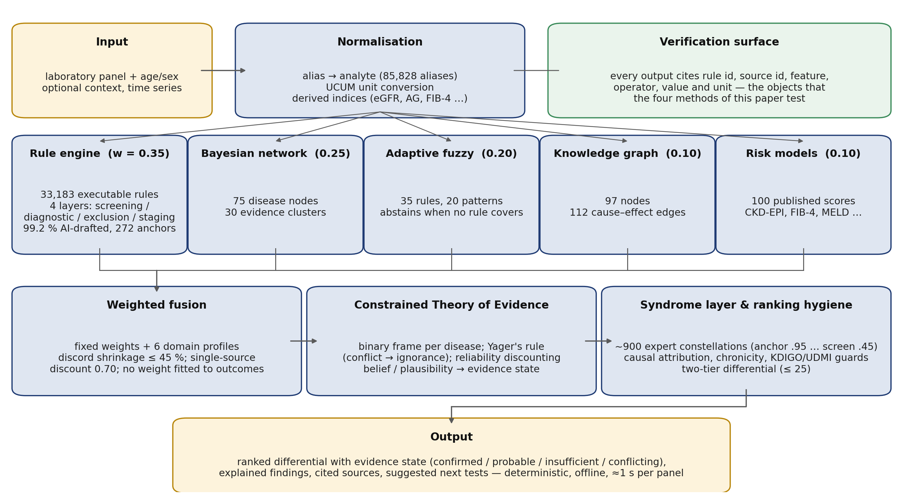
Fig. 1. Architecture. Panel, age/sex and optional context → UCUM normalisation and derived indices → rule layer (33,183 guideline rules) → expert syndrome layer → fusion → ranking hygiene (causal attribution, chronicity, UDMI) → two-tier cited differential.

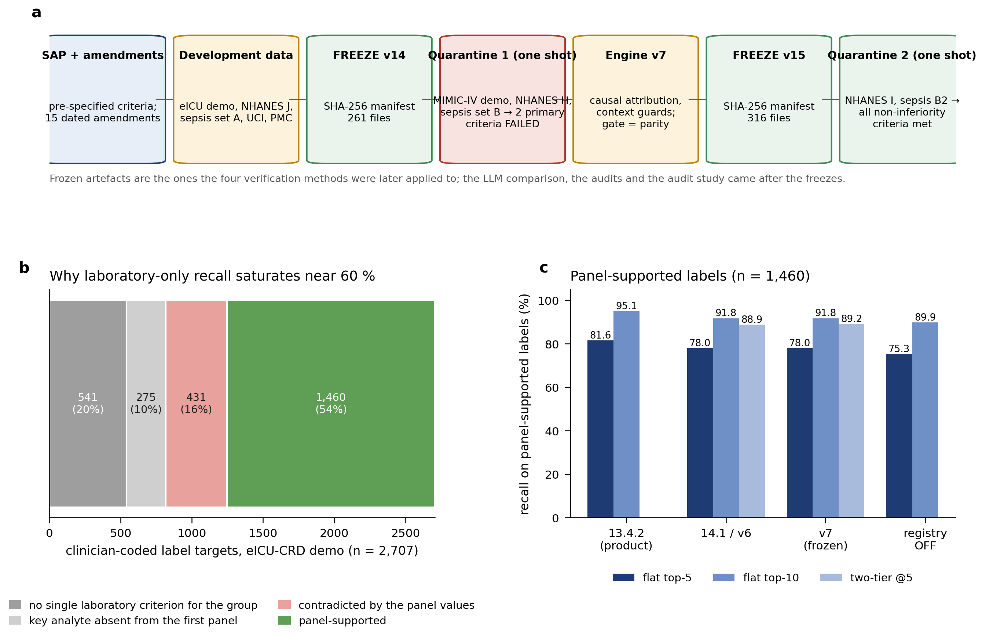
Fig. 2. Pre-specification workflow and the reference-standard ceiling. (a) SAP, freezes and the two one-shot quarantine rounds, including the failed round. (b) Decomposition of the 2,707 eICU label targets. (c) Recall on the 1,460 panel-supported labels for the product release, 14.1/v6, v7 and the registry-off ablation.

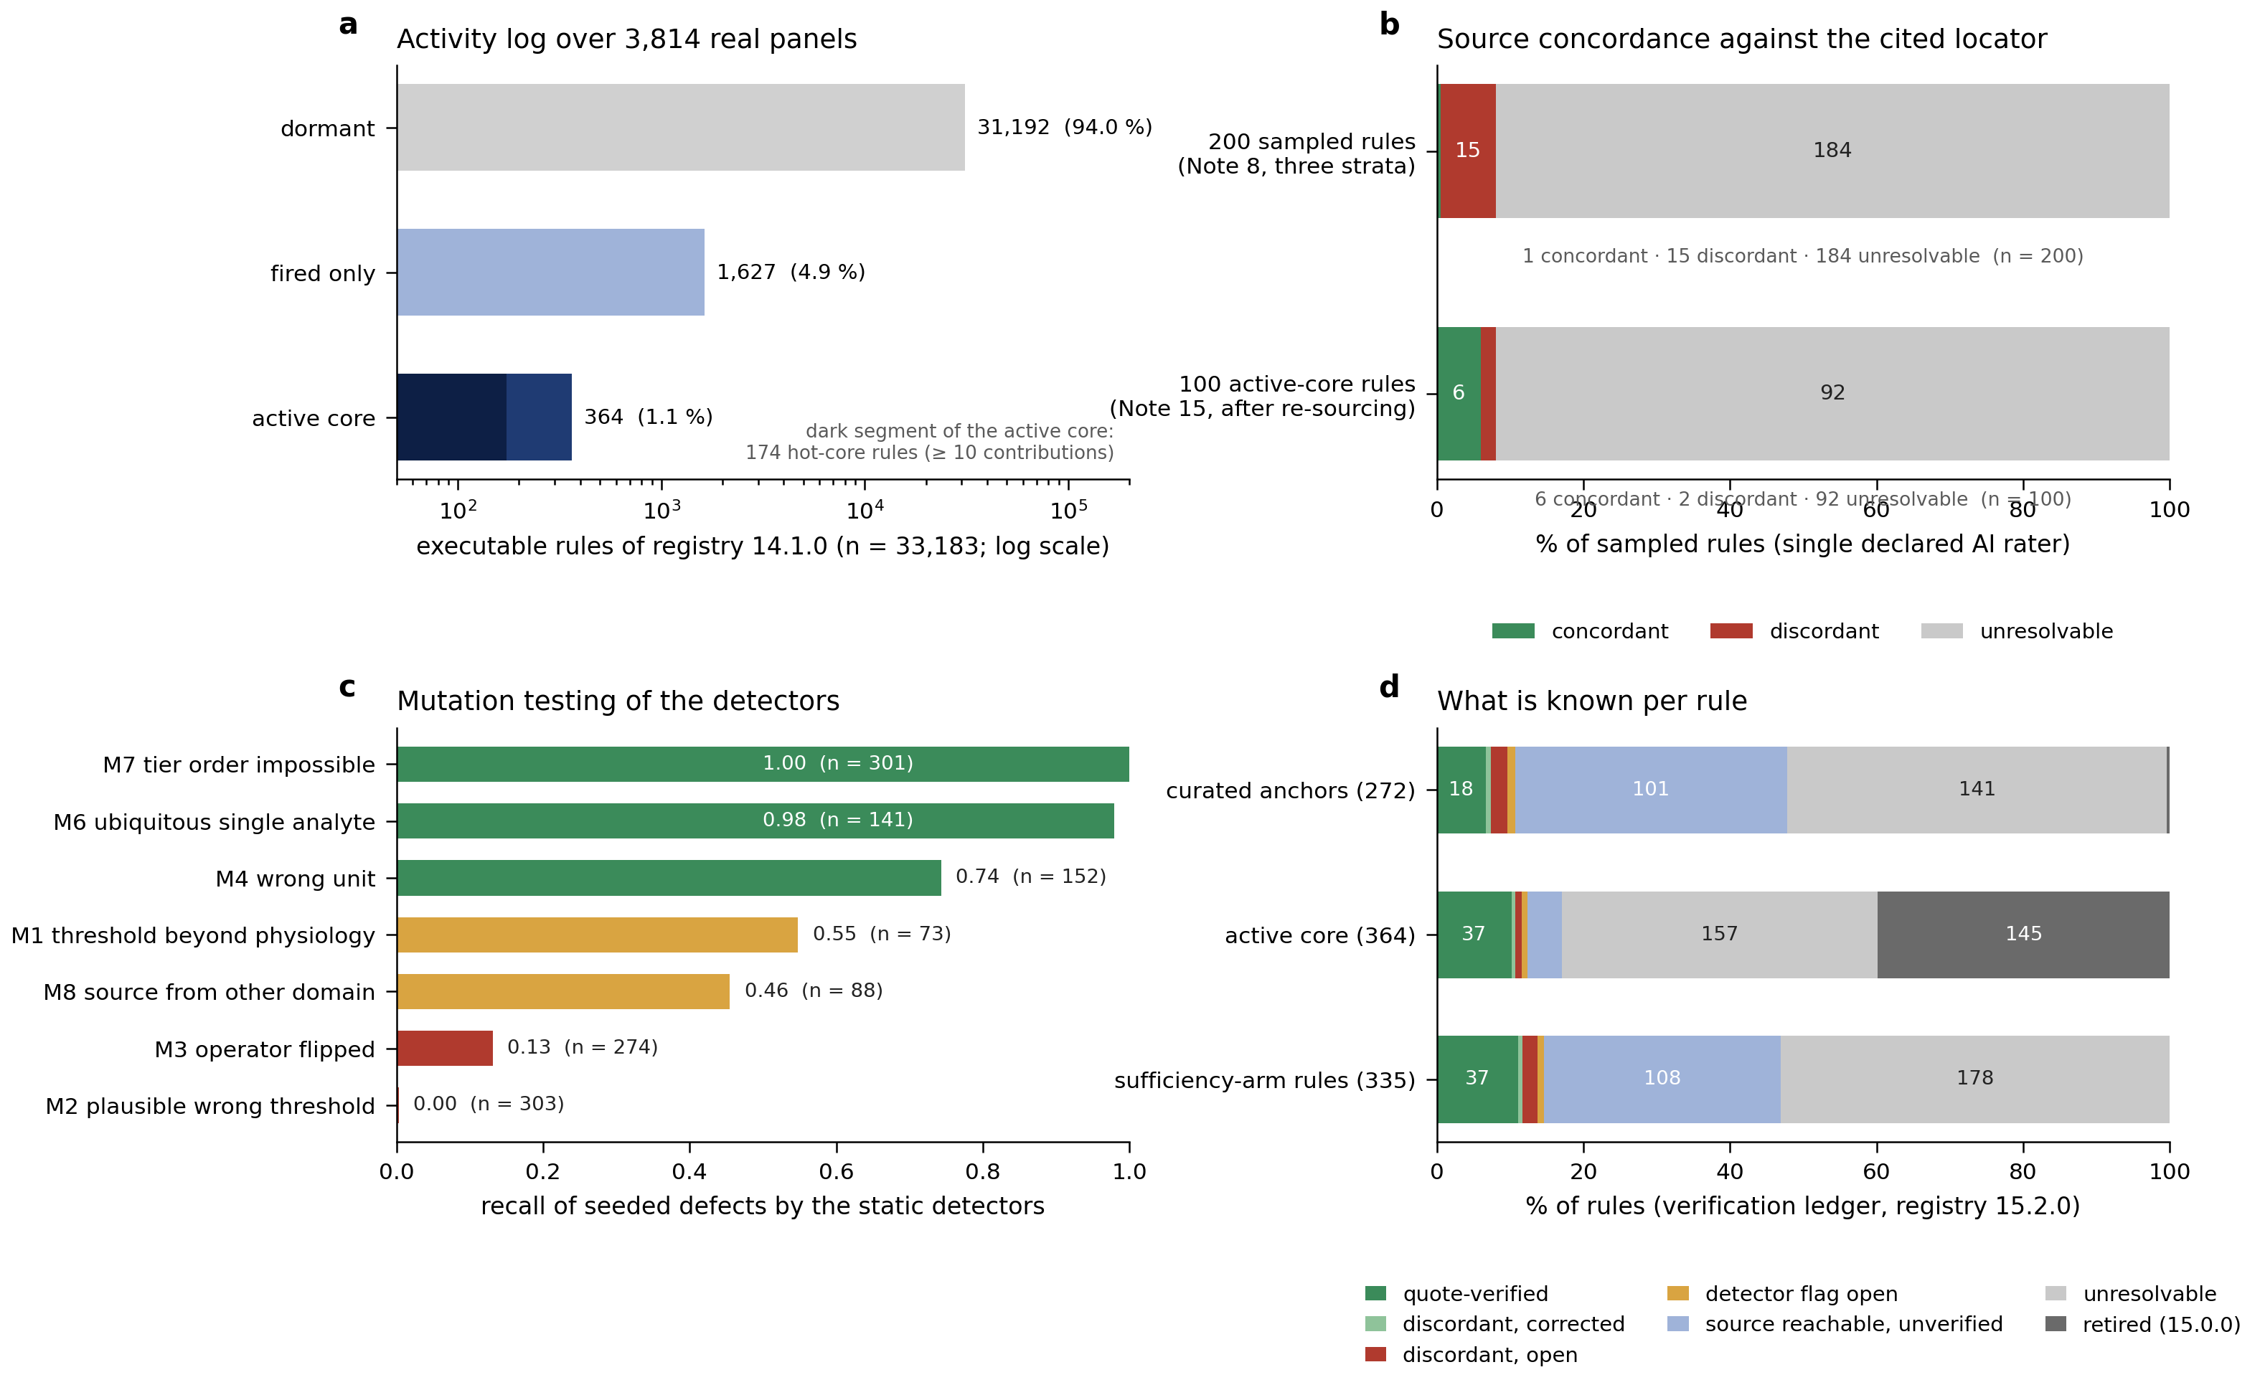
Fig. 3. What the verification methods established about the rule base. (a) Activity log over 3,814 real panels: 31,192 of 33,183 executable rules never fired, 1,627 fired without ever entering a top-10 differential, 364 formed the active core (174 hot). (b) Source concordance of the 200-rule frozen sample and of 100 active-core rules after re-sourcing (single declared AI rater). (c) Recall of seeded defects by the static detectors (mutation testing, Supplementary Note 16). (d) Per-rule verification ledger (Supplementary Note 18): status of the curated anchors, the active core and the sufficiency-arm rules in registry 15.2.0.

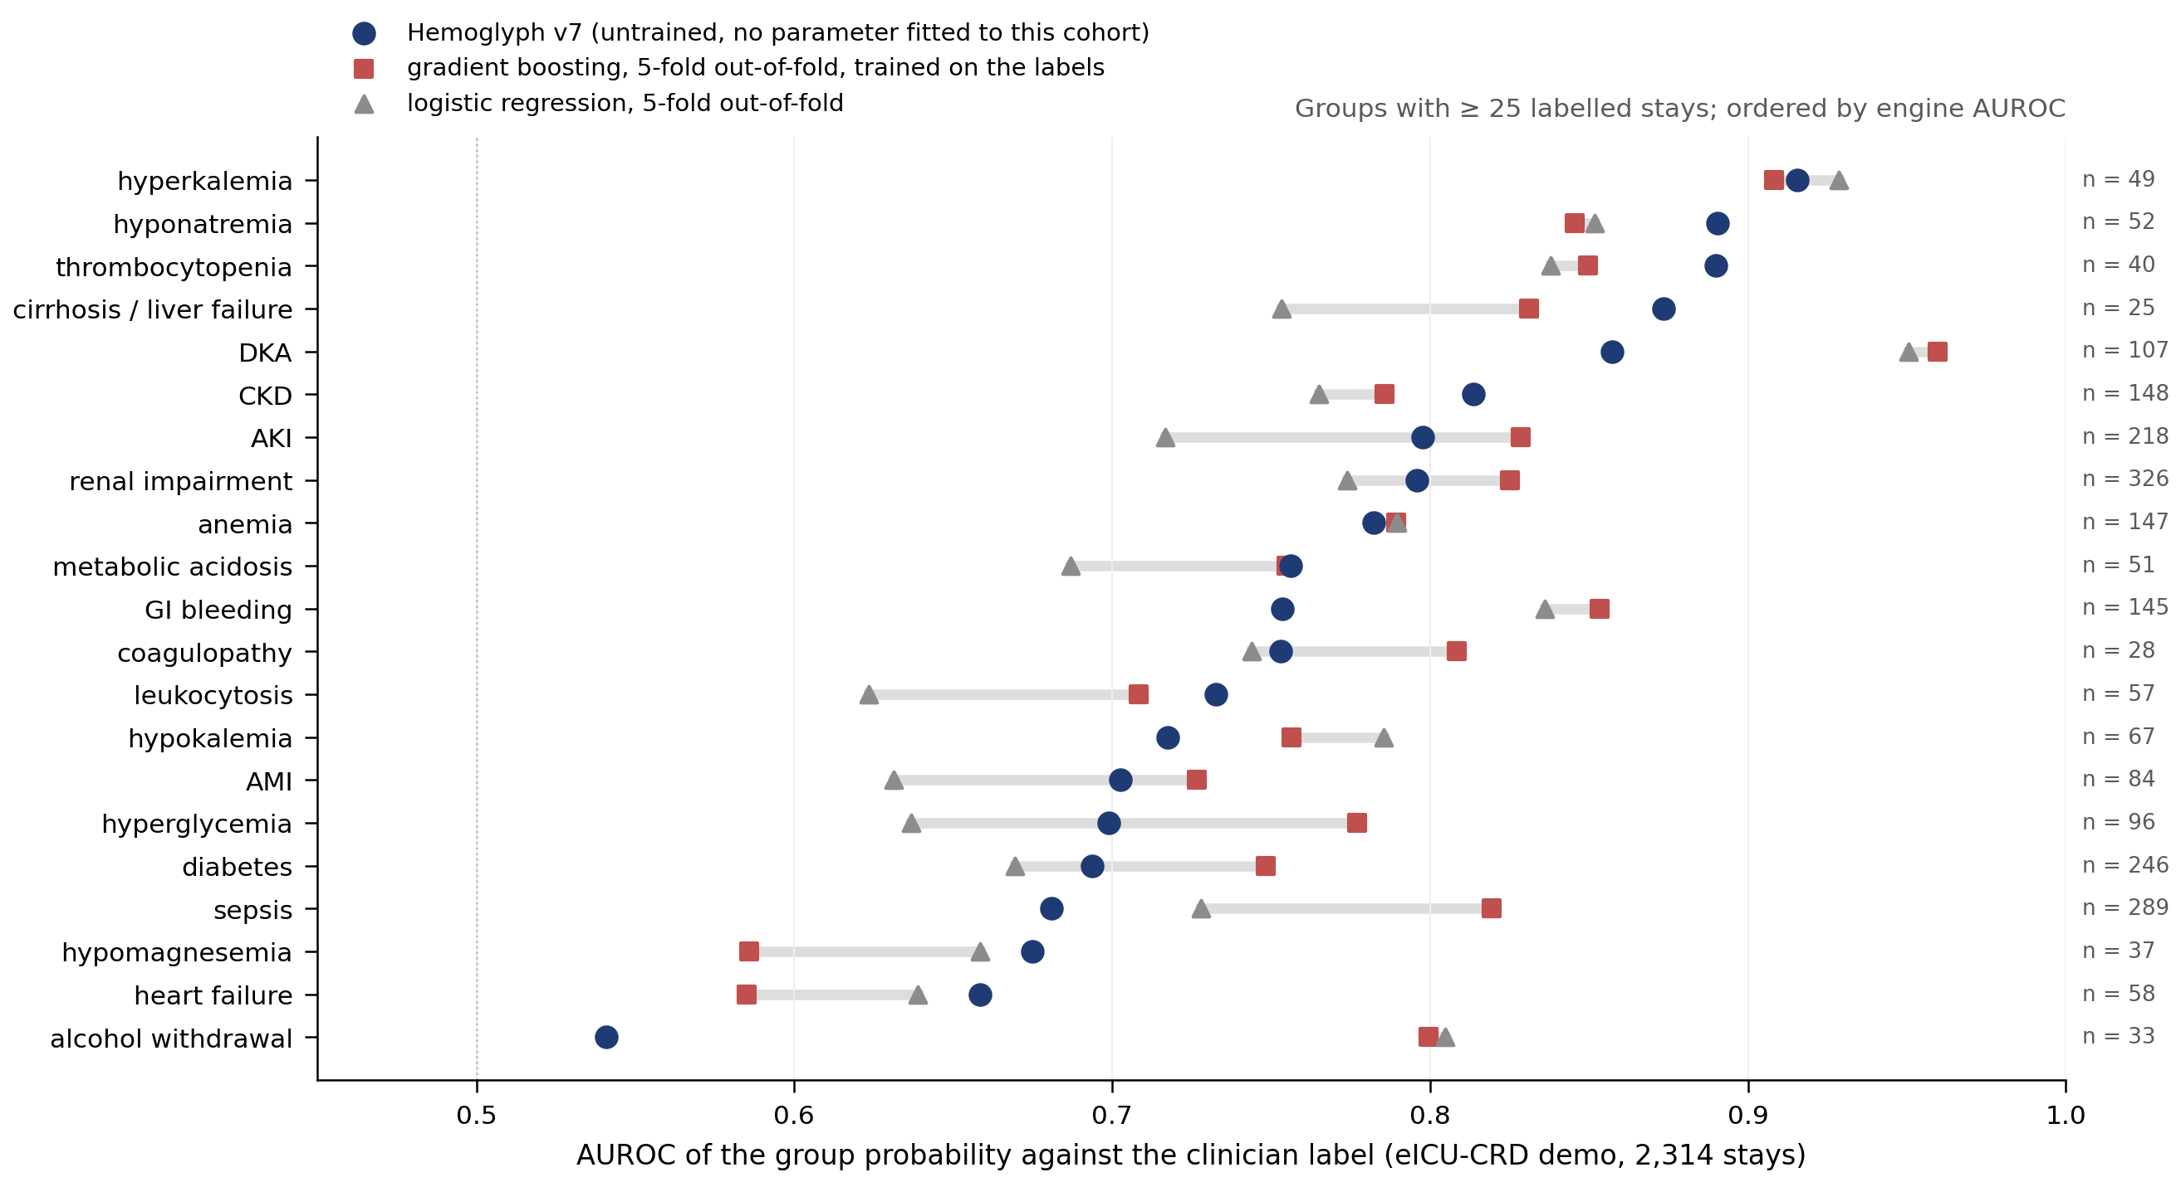
Fig. 4. Untrained engine versus supervised models on identical inputs (eICU). Per-group AUROC of Hemoglyph, five-fold out-of-fold gradient boosting and logistic regression.

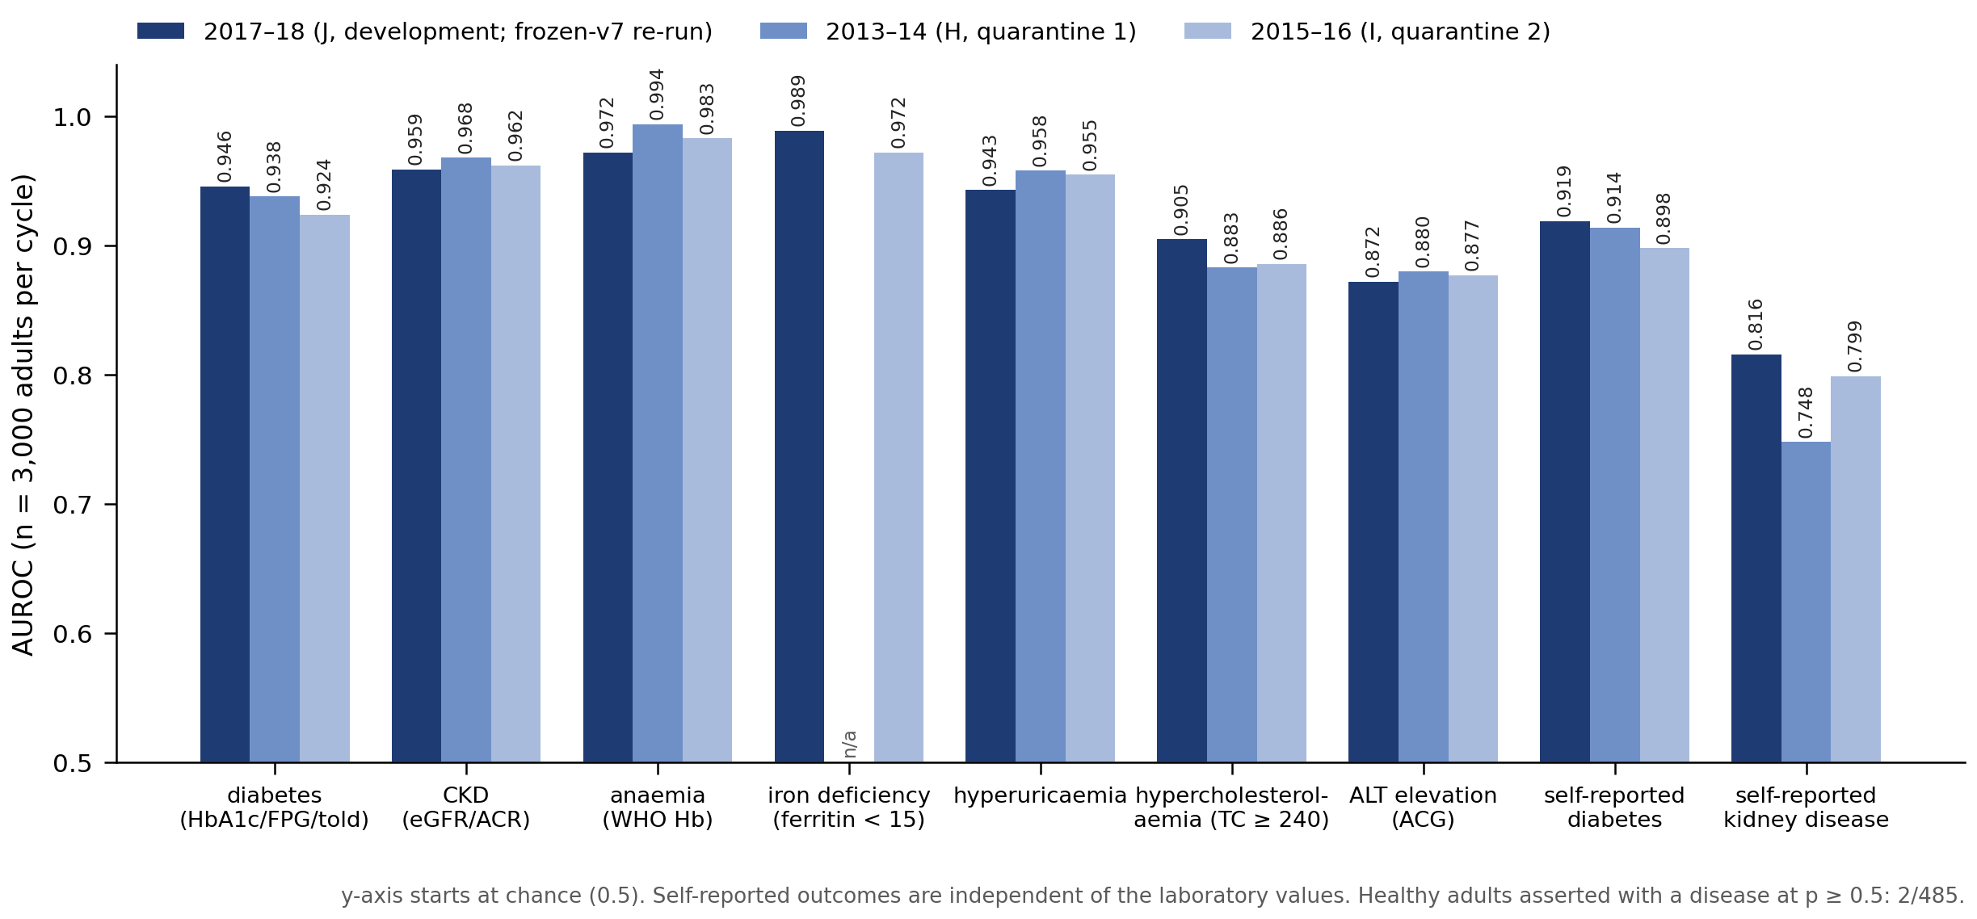
Fig. 5. NHANES screening across three independent cycles. AUROC per task for the development cycle (2017–18, frozen-v7 re-run) and quarantine cycles (2013–14, 2015–16), n = 3,000 each; y-axis truncated at 0.5 (chance level) to resolve differences of 0.01–0.05.

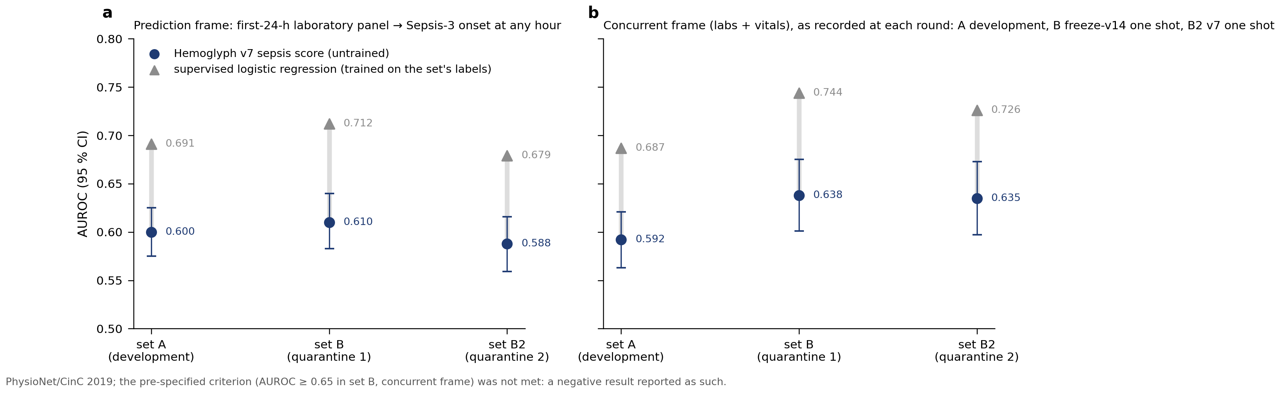
Fig. 6. Sepsis: a pre-specified negative result. Engine versus supervised logistic AUROC (95% CI) in the prediction frame (a) and the concurrent frame (b) across PhysioNet 2019 sets A, B and B2; concurrent values are those recorded at each one-shot round.

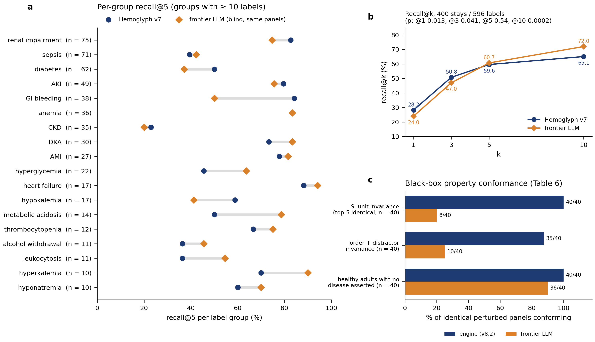
Fig. 7. Blinded LLM comparison and black-box property conformance. (a) Per-group recall@5 for groups with ≥ 10 labels and (b) recall@k curves, 400 stays / 596 labels, frozen engine v7 versus the unnamed frontier LLM; (c) conformance on identical perturbed panels (Table 6; engine v8.2).

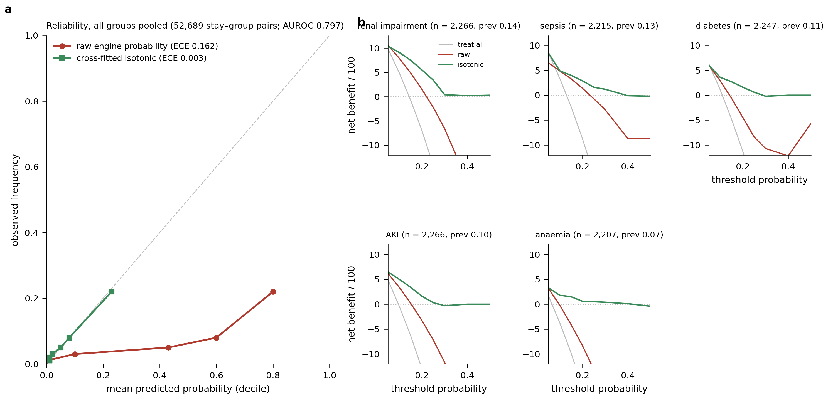
Fig. 8. Calibration and decision curves (eICU, engine v7). (a) Reliability by decile before and after cross-fitted isotonic recalibration, all groups pooled; (b) decision curves (net benefit per 100) for the five largest groups.

